Ta Quang Tung – 104222196

COS20019 – Cloud Computing Architecture - Wk5: ACF Lab 5: RDS lab

Task 1 - Create a Security Group for the RDS DB Instance

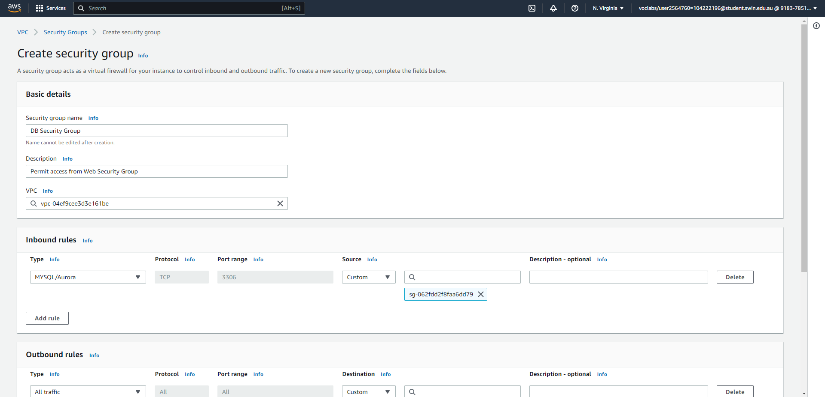



Steps 5-10: Create a new security group for the database with the required name, description, VPC, and inbound rule.

Task 2 - Create a DB Subnet Group

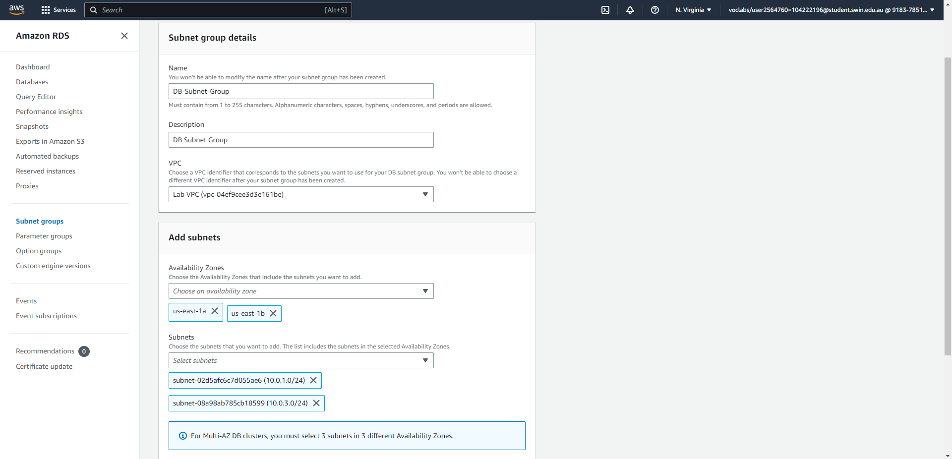



Steps 11-17: Create a new subnet group with the required name, description, VPC, and subnets.

Task 3 - Create an Amazon RDS DB Instance

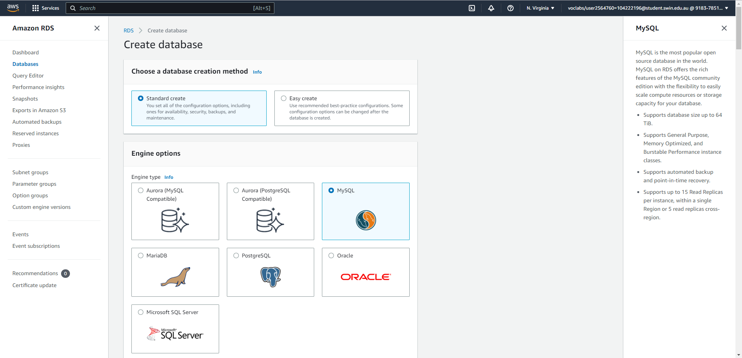



Steps 18-20: Choose MySQL engine.

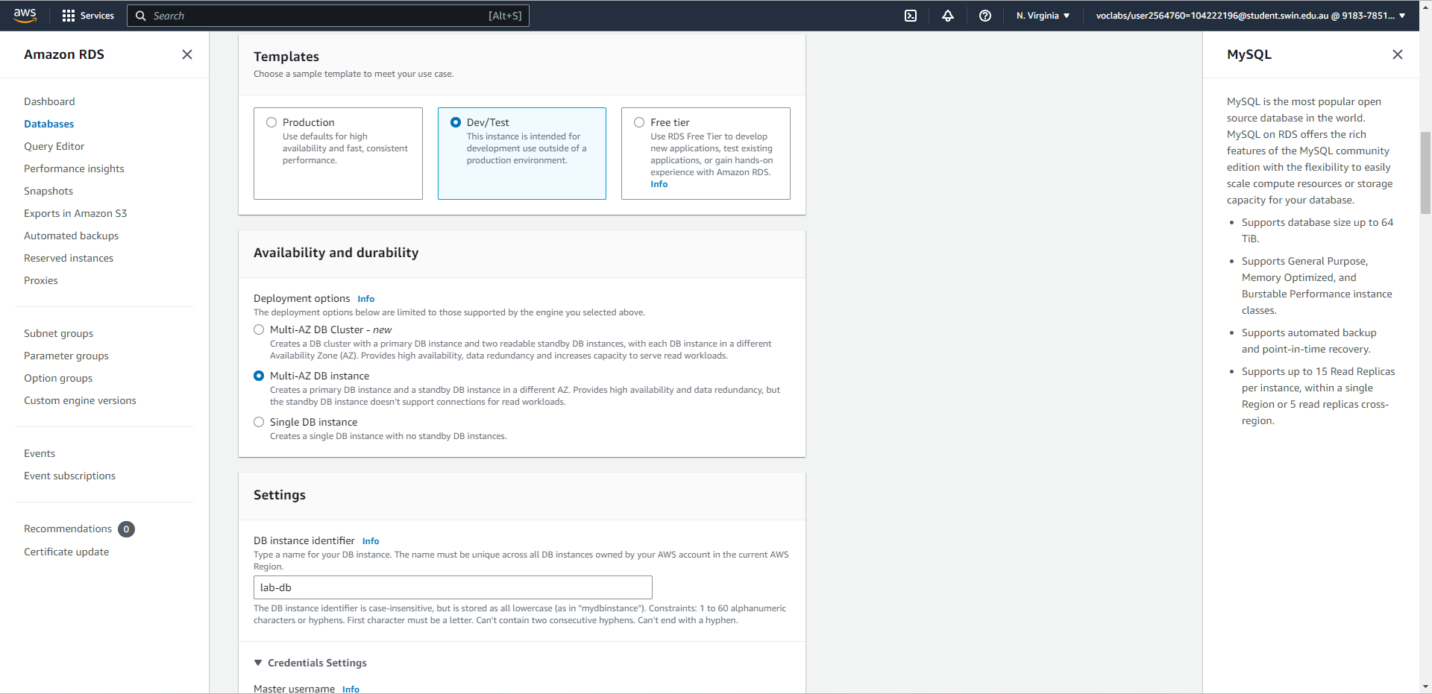



Steps 21-22: Choose Dev/Test template and Multi-AZ DB instance.

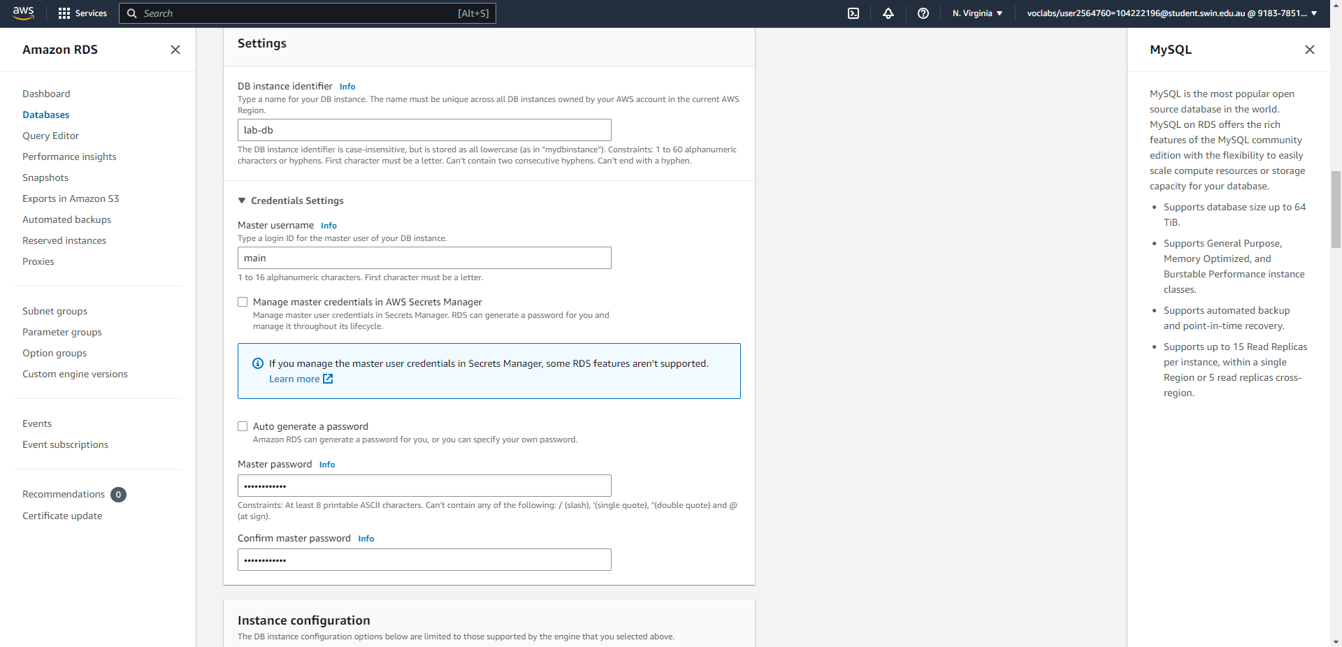



Step 23: Configure DB settings, including instance identifier, master username, and password.

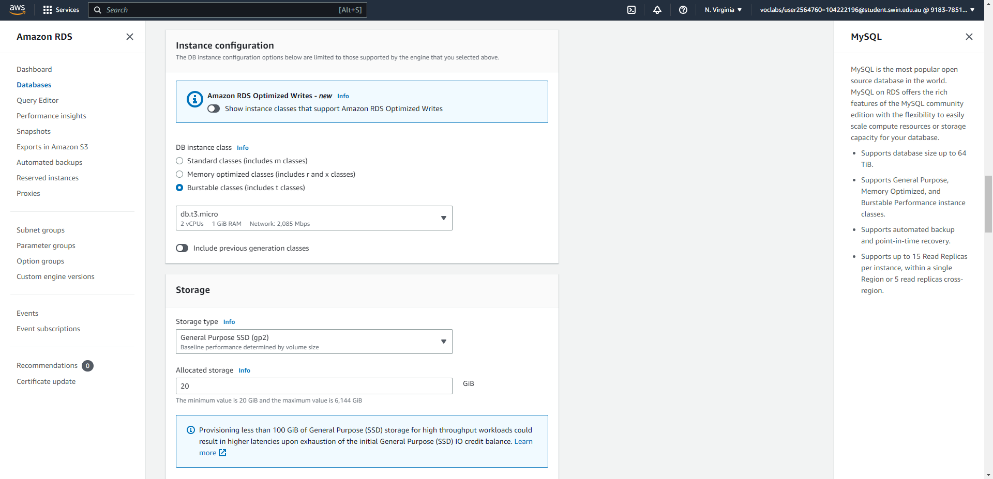



Steps 24-25: Choose burstable DB instance class, db.t3.micro, and configure storage setting to General Purpose SSD with 20GiBs of allocated storage.

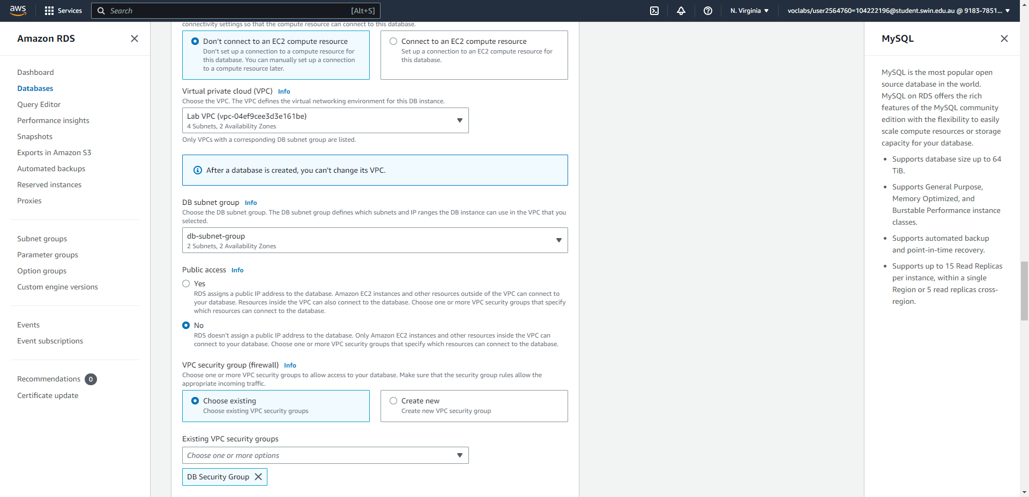



Steps 26-27: Select the Lab VPC, and choose only the DB Security Group created earlier.

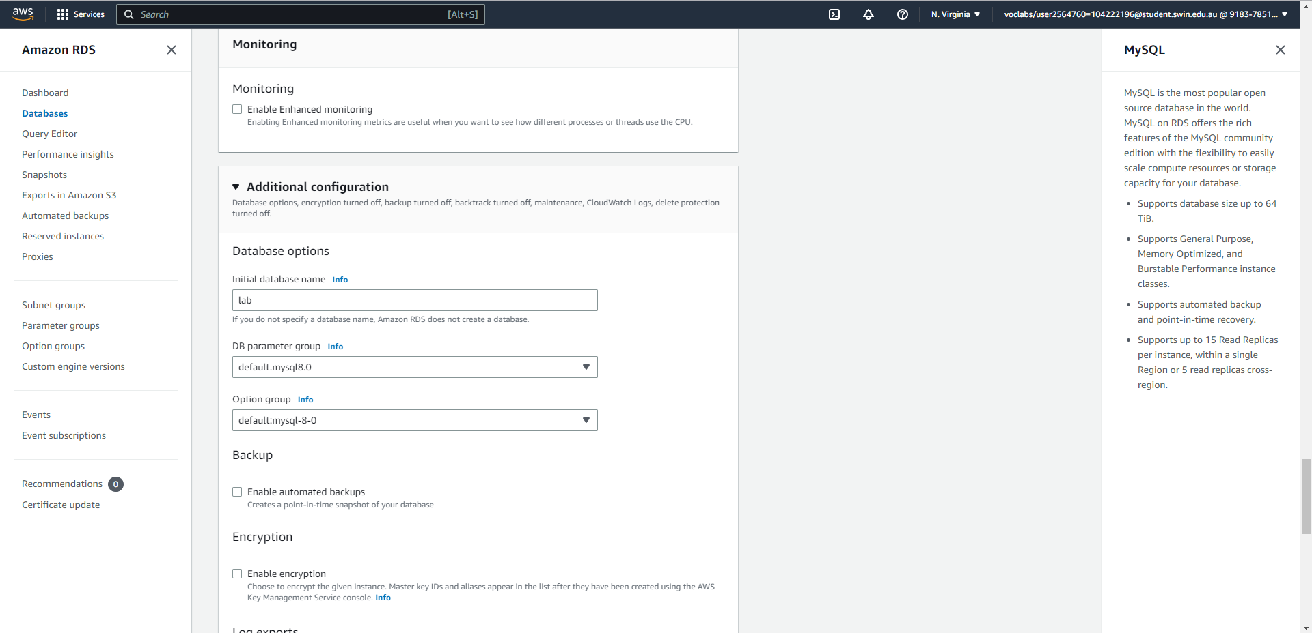



Step 28: Configure additional settings.

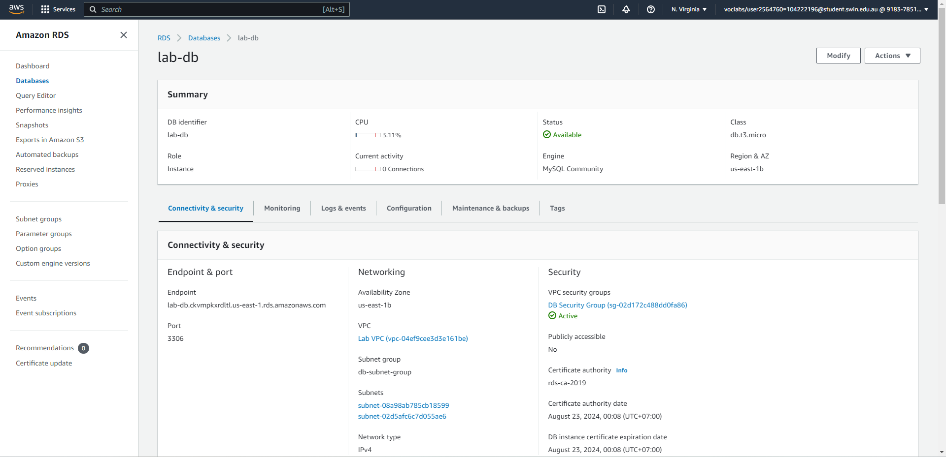



Steps 29-33: The database has been successfully created.

Task 4 - Interact with Your Database

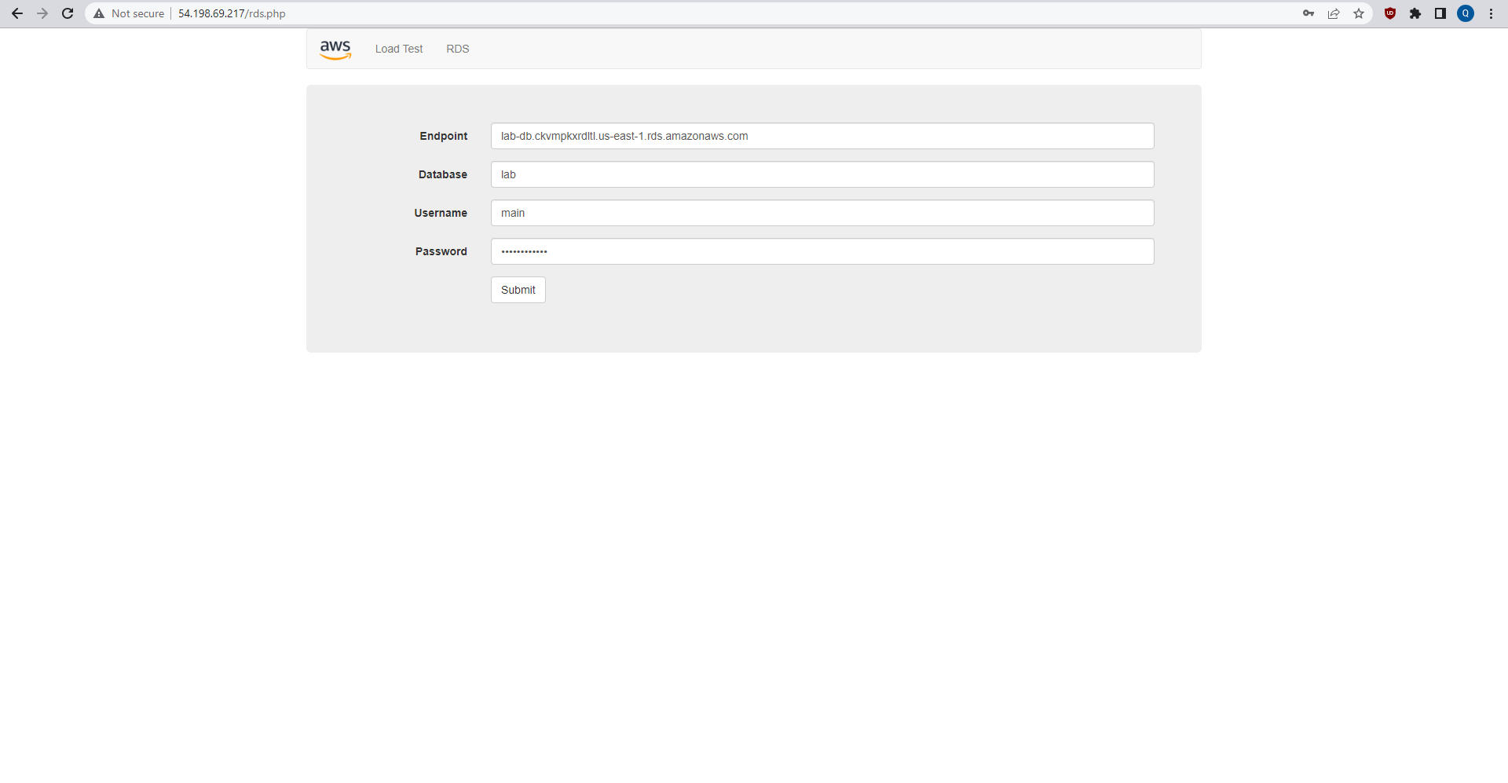

Steps 32-35: Accessing the database via the WebServer IP address.

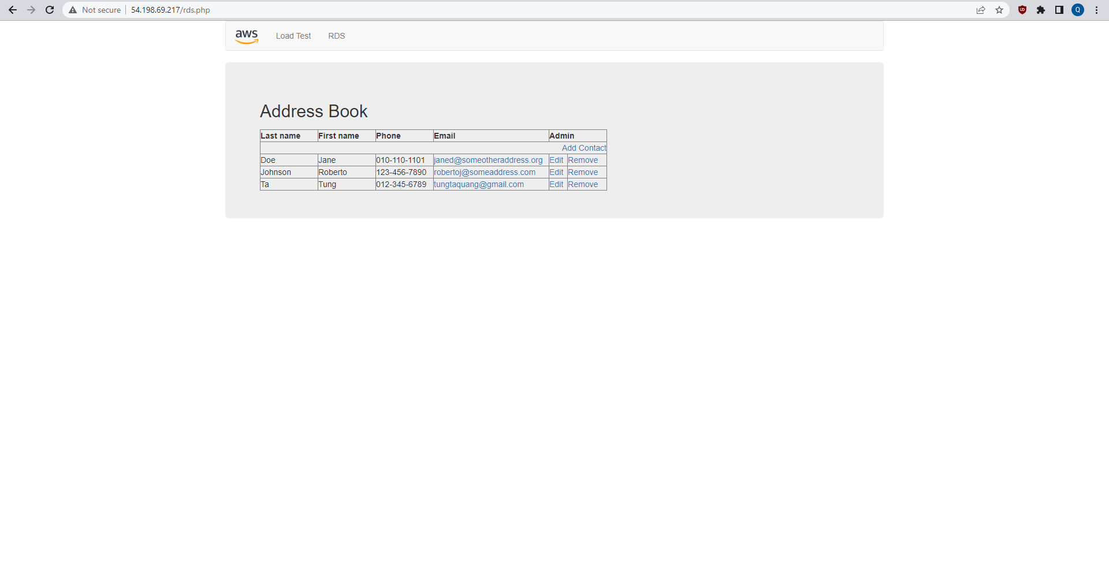

Step 36: The database’s data successfully shows. In this picture a new entry has been added.